Software Report

**Minimum Specification Features:**

The ability to sequence at least 2 synth tracks and the ability to sequence 2 sample tracks:

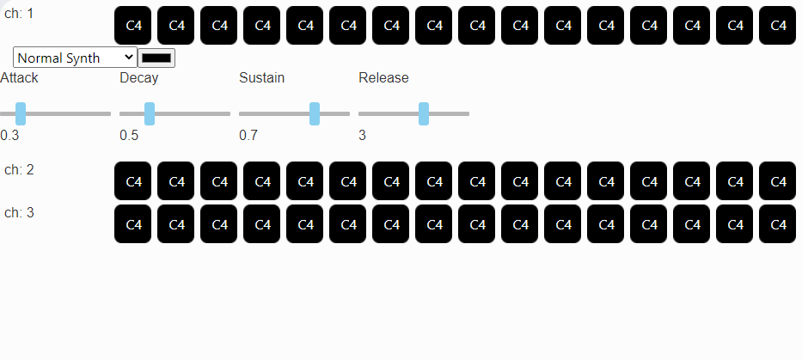This sequencer gives the user the ability to add as many tracks as they need, and the source of each track can be altered by choosing from a drop-down list that contains multiple styles of synth and an option for a sampler. *This feature has been fully implemented.*

Audio tracks have a choice of samples:

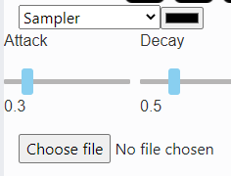Each audio track made has the ability to play a different sample which the user can upload themselves as long as it has a .mp3 or .wav file type. These samples can be pitch shifted by changing the note being played at each step. This feature is effectively fully implemented however, I could add more file types to the allowed list. To do this I would have to test other file types to see if they are compatible with the tone.js library.

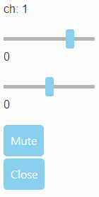Volume control for each track:

In the mixing desk channel, for each track, there is a slider to control volume in decibels this has a range of -60db ~ 20db. *This feature has been fully implemented.*

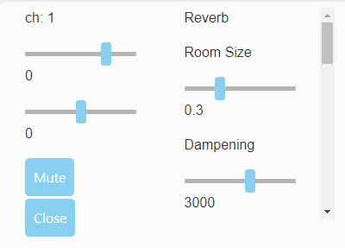Use of an audio effect:

In the mixing desk channel, there is a menu the use can open which holds multiple effects which the use can apply to the signal path. This has been functionally fully implemented however, I could implement more effects, so the user has more choice.

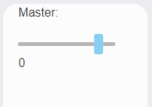Control of overall volume:

To the right of the mixing desk there is an area that contains the volume of the master output which all tracks are connected to. *This feature has been fully implemented.*

The ability to start and stop the sequencer:

In the top left of the screen there are buttons labelled play and pause which play and pause playback of all sequences. To stop playback of an individual sequence the user can press the mute button in the desk channel. *This feature has been fully implemented.*

The ability to mute/unmute each track:

In the mixing desk channel, there is a button labelled “mute” which when clicked sets the source volume to -200db so its signal output is effectively nothing however, it remembers the channels volume from before and resets it when unmuting and you can also change the channels volume slider while muted and it will save the changed volume without affecting the muted source. *This feature has been fully implemented.*

A user-friendly GUI with appropriate elements controlling each of the above:

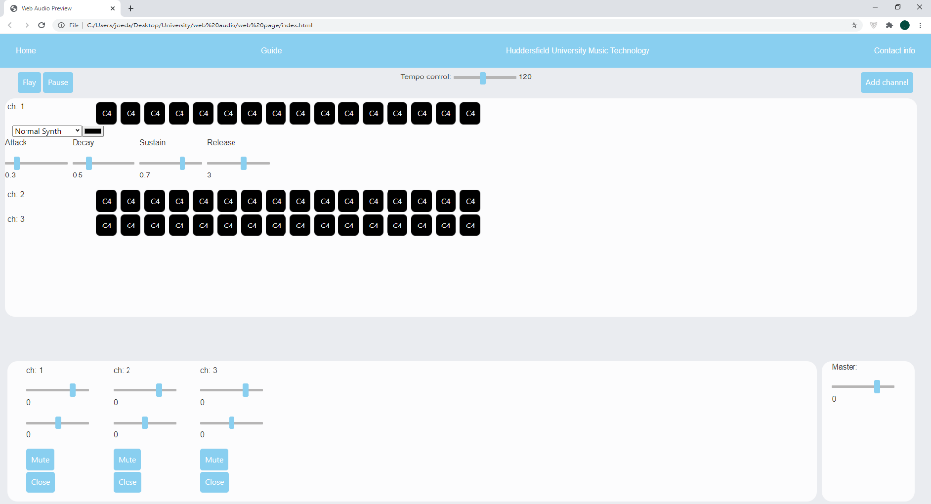I believe this sequencer has a sensible GUI layout, when designing it I tried to try and mirror layouts of other well-known DAWs that people would be familiar with. For example, the tracks go across the centre of the screen with the name on to the left of it, furthermore, the mixing desk runs along the bottom of the screen with a master volume control to the right of It, finally along the top of the screen I have the play and pause buttons and tempo control. *This feature has been fully implemented.*

**Additional Features:**

Dynamically add and remove sequences:

This sequencer allows the user to add as many sequences as they require and remove any they would like to remove, in any order. *This feature has been fully implemented.*

Dynamically order multiple effects:

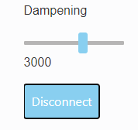When adding multiple effects this sequencer applies the newest effect onto the end of the signal path before connecting the path back to the master. And when removing effects from the middle of a signal path it connects the node that comes before and the node that comes after the removed node and connects them together. This allows the user to apply multiple effects in any order they want and remove effects they do not want in the middle and apply them to the end of the signal path. *This feature has been fully implemented.*

Ability to change tempo:

At the top of the screen there is a slider labelled tempo which controls the bpm of the track in real time. *This feature has been fully implemented.*

Manipulation of notes:

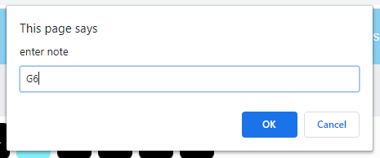By clicking on a step with the middle mouse button the user can input a new note that the sequencer will play instead of the default (C4), This can also be used to pitch shift a sample. After a new string is input the program checks it is in a valid note format using regex. *This feature has been fully implemented.*

Channel Panning:

In the mixing desk channel underneath the volume slider there is a pan slider which controls how far left and right the pan of the volume is. *This feature has been fully implemented.*

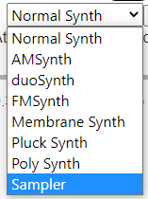Changing synth type:

Each sequence allows you to change its source by choosing from a drop-down menu containing multiple styles of synth and an option for a sampler. *This feature has been fully implemented.*

Editing synth envelope:

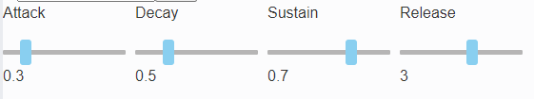Within the sequencer options menu there are four sliders which control each synth’s ADSR envelope. These values are all saved to each synth when you change them so for example if you apply an envelope you like to an FM synth then change to a duo synth the duo synth will have a different envelope but when you switch back to the FM synth it will have your setting saved. *This feature has been fully implemented.*

Ability to use your own audio files as samples:

In the sequencer settings area when a sampler is chosen for the channel source there is a button labelled “chose file” to upload a sample to a track the user can click this and choose any audio file they like that is an mp3 or wav. *This feature has been fully implemented.*

Change channel name:

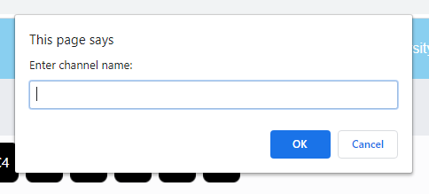In order to easily identify different channels this sequencer allows you to change its display name which can be done by clicking on the name in the desk channel or in the sequencer. When a new channel name is input the program checks the string to see if it is empty and will not allow the user to change name if new name is null or only white space (space or tab etc.). *This feature has been fully implemented.*

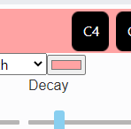Ability to colour code each channel:

In the sequencer settings area, there is a button which the user can press to change the channel colour, this will highlight both the sequencer track and the desk channel in the chosen colour. *This feature has been fully implemented.*